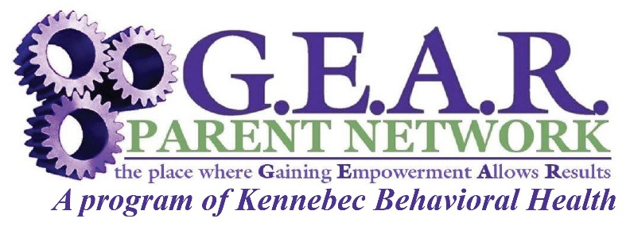

**10 Caldwell Rd, Augusta, ME 04330 • 1.800.264.9224 • www.gearparentnetwork.org**

**G.E.A.R. Parent Network Offers:**

**Maine and Nationally Certified Family Peer Specialists:**

* Emotional support
* 1:1 long term in-home family peer support
* 1:1 short term community support
* Child serving systems navigation
* Resources and referral to services
* Supportive phone calls, email and texts

**Empowerment & Training**

* Advocacy training to families and youth
* Educate child-serving systems
* Educational workshops & conferences
* Behavioral Health Homes State Certification training of Family Peer Specialists

**Community Outreach**

* Community resource fairs
* Children’s mental health education
* Family social & recreational activities

**Public Policy**

* Identify needs of families & their children
* Advocate to ensure there is family voice in program design, delivery & evaluation
* Recruit & train family leaders

**Empowering Families**

We build on the unique strengths and values of families to promote resiliency factors

**Culturally Responsive**

We reflect in our support the diversity and culture of our state and communities

**Cross-System Partnership**

Collaboration with all child-serving systems and community partners

**Family-**

**Driven**

To ensure that all parents/caregivers are the primary decision makers for their child or youth.

**Lived Experience**

All staff are parents of a child/youth with an emotional, behavioral or substance use health concern

**Strengthening Communities** by developing partnerships and offering children’s mental health education to increase action and reduce stigma!

**Supporting Maine Families**

statewide who are caring for a child/youth with mental, emotional, substance use or behavioral health concerns