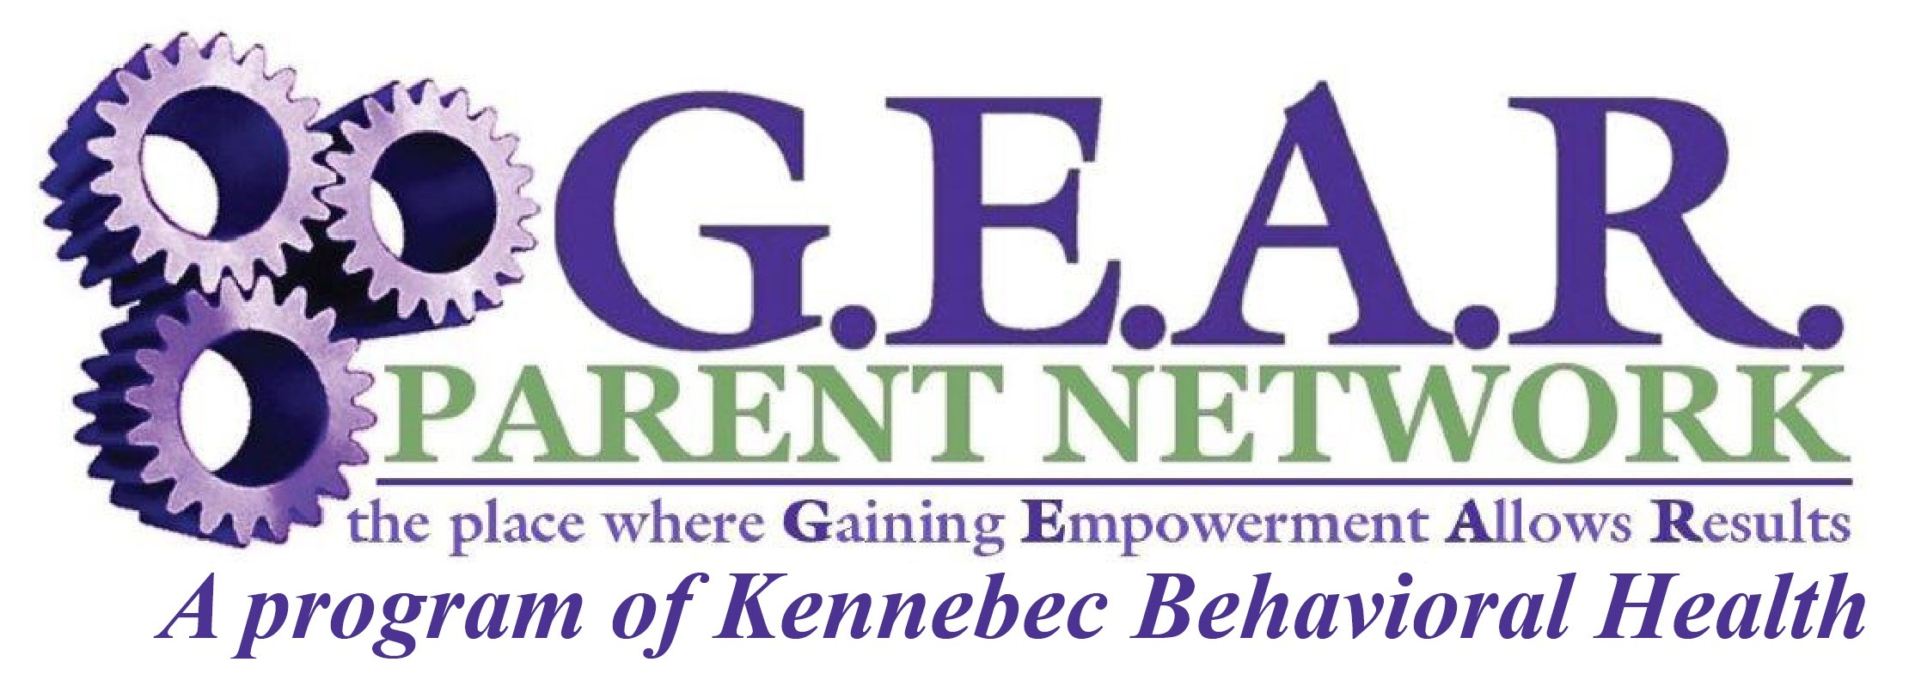


PARENT-PEER LEADERSHIP INSTITUTE

Maine Behavioral Health Home
Family Peer Specialist Certification Training

“Transforming Families and Systems through Parent Knowledge and Their Lived Experiences”

Dates: September 22, 24, 26, 2025 (a 3-day certification training)
Location: 10 Caldwell Road, Augusta
Held from: 8:15 a.m.to 5 p.m. with 30-minute lunch break
Cost: $450 per person

Contact: G.E.A.R. Parent Network Director, Cindy Seekins, Director at cseekins@kbhmaine.org for a PPLI training application form or print out near bottom of home page at https://gearparentnetwork.org/

Applicants are vetted to ensure they fully meet the following criteria:
1. Applicant has minimum of 3+ years of lived experience in parenting or in a parenting role (meaning biological parent, caregiver, foster parent or grandparent) with at least one child/youth whom lived with you for 3 or more years who has emotional, developmental, behavioral, substance use or mental health concerns.

2. Applicant is able and willing to articulate their lived experiences with that child/youth AND

3. Applicant additionally has 3+ years of lived experience with that one child/youth in navigating some or all of the child serving systems of care such as children’s behavioral health, child welfare, special education or juvenile justice on behalf of that child. (Note: both the # of years of lived experience and navigating SOC is determined/calculated from the date your when child/youth received their first mental health diagnosis to today’s date. (Not from time of their birth) With caregivers, foster parents or grandparents it would be from date the child/youth came to live with you to today’s date if still living with you or the date they left placement)

Training includes: PPLI training curriculum binder with additional tools and resource materials. Covers training in the 11 Domain Areas (as required by Maine and set forth by the National Certification Commission for Family Support for Family Peer Specialists) in addition their role/responsibilities plus bonus topics. Graduates receive a certificate of certification as a “BHH Family Peer Specialist” as required for employment in Maine Behavioral Health Homes. In accordance with the Family Peer Specialist Code of Ethics, FPS staff also will need continued education so they may remain current in all general areas of knowledge to follow laws and regulations, duty to persons served and duties to the profession and to abide by the standards of practice.

BHH Organizations – Are you in need of Family Peer Specialists now? We can help! G.E.A.R. Family Peer Specialists have dual Maine BHH and National Family Peer Specialist certifications and are available to help you meet the State BHH requirements for this role. We are available for short or long term; and you decide the number of hours monthly we can provide support and includes monthly progress notes! Call Cindy Seekins, Director at 207-441-7216 or email cseekins@kbhmaine.org to learn more!

Since its inception, family involvement has been a core value of systems of care and a core component of family involvement is the ability for parents and caregivers with lived experience and experience navigating services and systems to help other parents (e.g., parent-to-parent peer support).

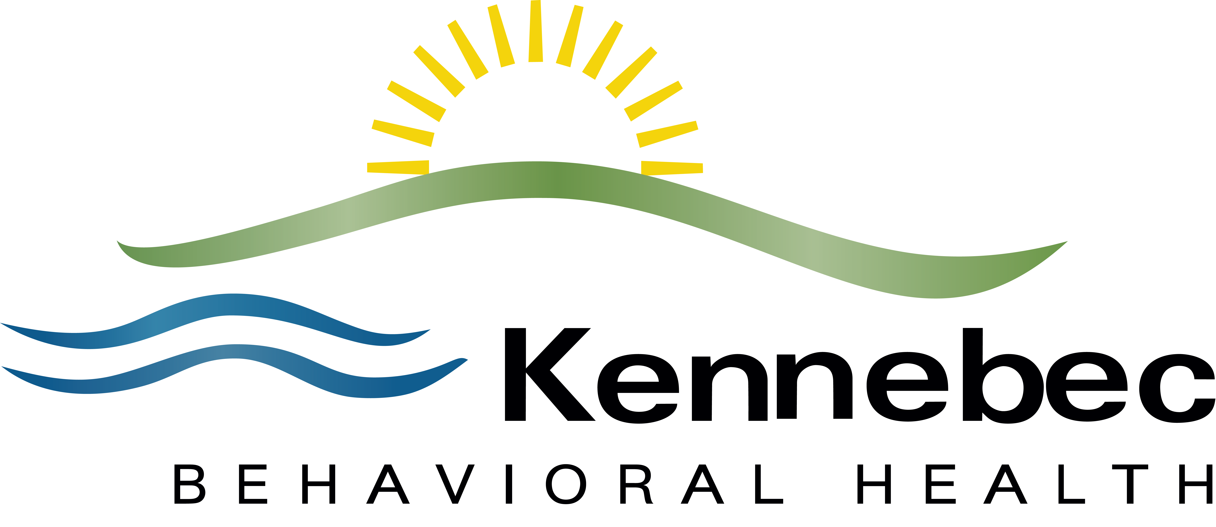

G.E.A.R. Parent Network is a Parent-to-Parent Network of Information & Support for Parents of Children with behavioral health needs,

is a program of Kennebec Behavioral Health and is funded by the Department of Health & Human Services, the United Way and Private Donations

Administration: 10 Caldwell Rd, Augusta, Maine 04330 • (207) 626-3448 (voice & TTY); Fax (207) 626-3453

