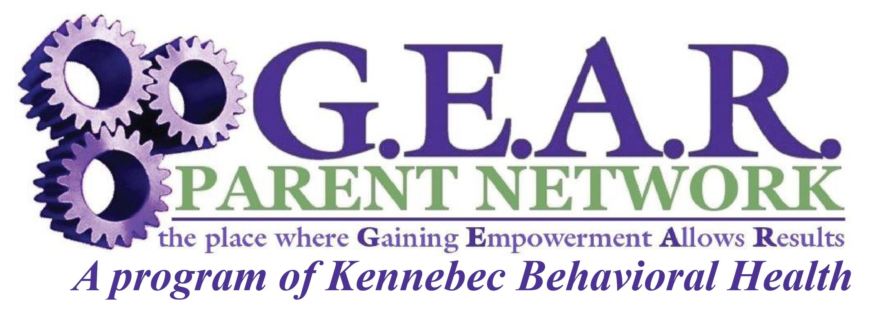

PARENT-PEER LEADERSHIP INSTITUTE

Family Peer Support Specialist Certification Application for Maine Behavioral Health Homes

Application Date: ___________
Applicant Name: _______________________________ Agency: _________________________
Mailing Address: _______________________________________________________________
Work Phone: ___________ Cell: ___________ Email: ______________________________
Supervisor Name & Email address: _________________________________________________
Completion of this application/registration provides information to help determine if the applicant meets the criteria below for the parent/family peer specialist role. To qualify the applicant must be a parent/caregiver who also is able/willing to articulate their lived experiences of parenting a child with emotional, developmental, behavioral, substance use or mental health concerns. The effectiveness of a Parent/Family Peer is related to their lived experience as a parent caring for their child/youth and in navigating the child serving systems of care. Note: At least 3+ years of lived experience is strongly recommended for this role. (Years of parents lived experience is determined from the date their child/youth received their first mental health diagnosis to today’s date and not from time of their birth)

- Please check ONE:
- I have 3+ years of lived experience in the parenting role of (guardian, foster parent, grandparent, caregiver) of a child who has emotional, developmental, behavioral, substance use or mental health concerns.
- I have 3+ years of lived experience as a parent of a child/youth with emotional, developmental, behavioral, substance use or mental health concerns.

- Number of years of lived experience: _____ (Note: This is determined from the date a child/youth received their first mental health diagnosis to today’s date and is not from time of their birth. For caregivers/foster parents or grandparents this is determined from date one child began living with you to todays date or date they left your home)

- I have 3 + years of lived experience navigating the child serving systems of care advocating on behalf of my one child/youth (children’s behavioral health, child welfare, special education or juvenile justice systems) AND I am able and willing to articulate and communicate the experience of parenting a child with emotional, developmental, behavioral, substance use or mental health concerns to other parents. ____Yes ____No

- I understand that after acceptance of this application, I do commit to completing the three full days of training listed below: ____Yes ____No

Dates: September 22, 24, 26, 2025 (a 3-day certification training)
Location: 10 Caldwell Road, Augusta
Held from: 8:15 a.m.to 5 p.m. with 30-minute lunch break
Cost: $450 per person

Full Payment of $450 is included in this application: ____Yes ____No
Full Payment will be submitted by first day of training: ____Yes ____No

Please return this application along with payment to: c/o Cindy Seekins, Director, G.E.A.R. Parent Network/Kennebec Behavioral Health, 10 Caldwell Rd, Augusta, ME 04332 or FAX 207-626-3453. For more information call 207-441-7216 or 1-800-264-9224.

